**Date: January 25, 2022**

**Topic: Subtlety of ER diagrams**

**Learning objective:** Understand subtlety involving weak entity sets, 2-way relationships or 3-way relationship sets, aggregation, and ISA hierarchy.

**Reference materials:**

[1] <http://pages.cs.wisc.edu/~dbbook/openAccess/thirdEdition/solutions/ans3ed-oddonly.pdf> Raghu Ramakrishnan and Johannes Gehrke. Database Management Systems, 3rd Edition 3rd Edition. McGraw-Hill Higher Education, 2003.

1. Given the ER diagrams in Figure 1 and Figure 2, answer the following questions.



Figure 1: ER diagram modeling a database of teaching assistants and course sections



Figure 2: ER diagram modeling a database of teaching assistants and course sections

* 1. Does the diagram in Figure 1 indicate that each student must assist in teaching some sections? If not, modify the ER diagram in Figure 1 to capture the requirement.

**No, because it has a thin line which means that it is not required.**

**Solution: bold the thin line going from Student to Assist**

* 1. Does the diagram in Figure 1 indicate that each section must have at least one teaching assistant? If not, draw the ER diagram that enforces such a requirement.

**No, it does not because it has a thin line instead of a bolded arrow going from Assist to Section**

**Solution: Change the line that goes from Assist to Section from thin to bolded and an arrow to show requirement.**

* 1. Is it possible to use existing ER diagram notations to indicate a constraint that a particular student is not allowed to assist a certain professor in teaching some sections either in Figure 1 or Figure 2? **No, ER notation apple to the whole entity set or relationship set, not just to a specific entity or relationship.**
  2. Compare the two ER diagrams in Figure 1 and Figure 2, which of the ER diagram requires that SemesterName must be provided when students assist in teaching course sections. **Figure 2 requires SemesterName and it can be seen since it is a unique identifier.**
  3. A relationship set is a set. What make a relationship in the “assist” relationship set unique in Figure 1? How about in Figure 2? **In figure 1 it is University ID, CID, and Section ID (Partial) for Figure 2 it is University ID, CID, Section ID (partial), and SemesterName**
  4. For the ER diagram in Figure 1, could we keep a history of assistantships for the same student assisting in teaching the same course section in different semesters?

**No because the Section ID, University ID for the student, and Course ID would stay the same and so only one instance can be kept.**

1. Add to the ER diagram we did last week to indicate the following requirement. An employee can have dependents. The dependent name, gender, date of birth, and the relationship of the employee and his/her dependent needs to be kept. Names of dependents for the same employee are unique. But different employees may have the same names for their dependents. Each dependent must be associated with exactly one employee.
2. Given the ER diagram below taken from the open material from Reference [1].

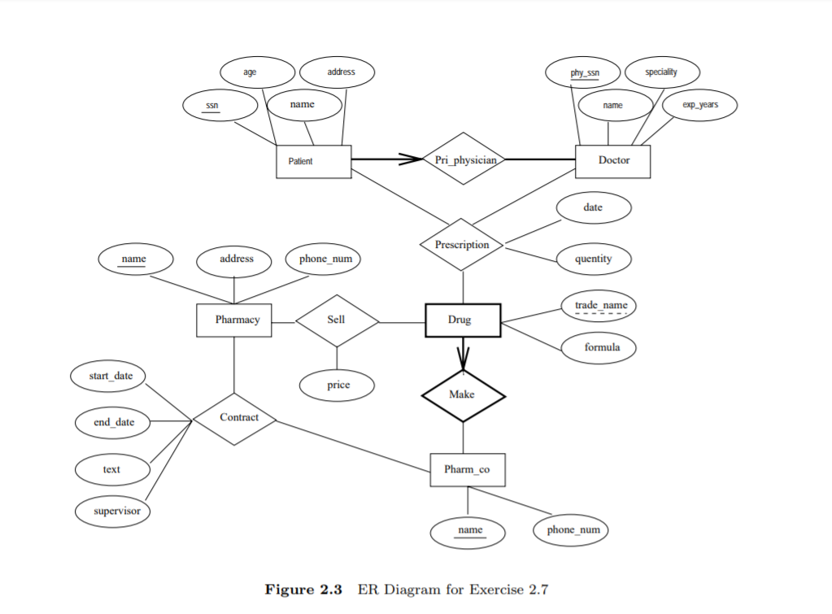

The “Prescription” relationship set is a 3-way relationship set among “Patient”, “Doctor”, and the weak entity set “Drug”.

* 1. Name the identifying relationship set of the weak entity set “Drug”.
     1. “Make”
  2. What makes each relationship in the “Prescription” relationship set unique?
     1. SSN(Patient), phy_ssn(Doctor), name(Pharm_co), trade_name(Drug)
  3. Could we store a history of prescriptions made to the same patient, same doctor, and same drug, but on different dates?
     1. No because date is just an attribute of prescription. If it were an entity set we could track history.

1. In the ER diagram below, each sponsorship must be monitored by at most one employee. If a sponsorship must be monitored, but can be monitored by more than one employee, what do you have to change in the ER diagram to model the new requirement?



Answer: We would have to change the arrow from **Sponsors** to **Monitors** to a bolded line